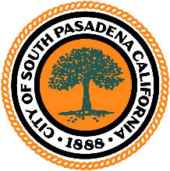
CITY OF SOUTH PASADENA
Council Chambers
1424 Mission Street
South Pasadena, CA 91030
Tel: (626) 403-7380
www.southpasadenaca.gov

CANCELLED
FESTIVAL OF BALLOONS
REGULAR MEETING

NOTICE IS HEREBY GIVEN that the regularly scheduled meeting of the Festival of Balloons Committee for Wednesday, February 22, 2023, at 7:00 p.m., has been cancelled.

Following this meeting, the next Festival of Balloons Committee meeting will be held on March 29, 2023, at 7:00 p.m. at the Senior Center.

Any questions regarding this information can be directed to the Community Services Department at (626) 403-7380. Thank you.

Date Posted: February 21, 2023

Sheila Pautsch
___________________________
Sheila Pautsch, Community Service Director

